1. **How many squares does a chess board have?  
   Ans.**
2. **What is the colour of the right-hand corner square nearest a player?  
   Ans.**
3. **How many chess pieces does one player have at the start of the game?  
   Ans.**
4. **Write name of all the chess pieces and relative value of the chess pieces.**

**Ans.**

1. **Write the notation where the Rooks are placed at the start of the game?**

**Ans.**

1. **What is the colour of the square where the White King is placed at start of the game?**  
   **Ans.**
2. **What is the colour of the square where the Black King is placed at start of the game?**  
   **Ans.**
3. **What is the colour of the square where the White Queen is placed at start of the game?**  
   **Ans.**
4. **What is the colour of the square where the Black Queen is placed at start of the game?**  
   **Ans.**
5. **Name the 4 Central Squares of the Chessboard.  
   Ans.**
6. **What are the symbols used for the pieces while writing move notations?**  
   **Ans.**
7. **How many squares do the following pieces control from the center (d4,d5 or e4 ,e5)  
   Ans.** King____? Queen____? Rook____? Bishop____? Knight____? Pawn____?
8. **Who starts first in chess? White or Black?  
    Ans.**
9. **What is the colour of the following squares?  
   Ans.** a1__________? f7__________? b7__________? d6__________? g1__________?
10. **Name of the squares on which the following pieces are located at start of the game?  
    Ans.** White King___? Black Queen___? Black Rooks___&___? White Bishops___&___?
11. **Name the squares from where Knight can move to only other 2 squares?  
    Ans**
12. **Which is the only piece which can jump over its own and opponent’s pieces?**
    1. Pawn
    2. Knight
    3. Bishop
    4. Rook
    5. Queen

**Ans.**

1. **The Knight moves in what letter shape?  
   Ans.** T Z L V X
2. **The Bishop moves in what letter shape?  
   Ans.** T Z L V X
3. **How does the Pawn capture?**
   1. Backwards
   2. Sideways
   3. Forwards
   4. Diagonally

**Ans.**

1. **Which is the only piece that cannot move to a different colored square during the course of the entire game?**
   1. Rook
   2. Knight
   3. Bishop
   4. King
   5. Pawn

**Ans.**

1. **What is the name of the special move which involves moving King and Rook at the same time?  
   Ans.**
2. **How many squares can a King move while castling?  
   Ans.**
3. **Can a player Castle with a Rook which is under attack?**

**Ans.**

1. **Can a player Castle with a King if it is under attack?**

**Ans.**

1. **Can a player Castle if the king or the Rook has already moved?**

**Ans.**

1. **What are the chess notations used for King side and Queen side Castling?  
   Ans.**
2. **What are the three options of getting out of check?  
   Ans.  
   When can the Pawn be promoted to a new Queen, Rook, Bishop or Knight?  
   Ans**
3. **Queen side Castling is called Short Castling or Long Castling?  
   Ans.**
4. **What is the name of the special pawn capturing move?**

**Ans.**

1. **Can a white Pawn on a5 capture the pawn on b5 which has moved from b7 in one move?  
   Ans.**
2. **Can a Black Pawn on e3 capture the d2 pawn, which has moved to d4 square in one move?  
   Ans.**
3. **Which of the following is true about a Pawn?**
   1. A pawn can give a check.
   2. A pawn is pretty useless and can be sacrificed always.
   3. A pawn can promote only into a queen.
   4. Pawns can always only move one square at a time.

**Ans.**

1. **Which of the following is true about a rook?**
   1. A rook is always stronger than a bishop and a knight together.
   2. A rook can jump over pawns.
   3. Two rooks have roughly the same value as a queen.
   4. I leave my rooks sitting in the corner until the endgame arrives.
   5. Three pawns have the same value as a rook.

**Ans.**

1. **What happens if the King cannot get out of Check? Ans._____**
2. **What is stalemate?**
   1. Stalemate is the same as checkmate.
   2. If the enemy king is in stalemate I win.
   3. If the enemy king is in stalemate I lose.
   4. A king that is in stalemate must be in check at the same time.
   5. If the enemy king is in stalemate the game is a draw.

**Ans.**

1. **What is true about Knight?**
   1. Knight is stronger than a bishop because it can make a fork.
   2. Knight is stronger than a bishop because it can go white and black squares.
   3. Knight is very powerful at the edge of the board.
   4. Knight can jump over other pieces.
   5. Knight has usually more value than four pawns.

**Ans.**

1. **What is the situation called where a player has no legal move to make and his king is not under attack? Ans.**
2. **Are you required to move a Piece you have touched?  
   Ans.**
3. **Which is the only piece in CHESS that can never be captured?  
   Ans.**
4. **What is true about Bishop?**
   1. Bishop can move on same colour. That's why it is weaker than a knight.
   2. Bishop needs open diagonals to show its strength.
   3. Bishops can jump over pawns.
   4. Two bishops are stronger in blocked positions than two knights.
5. **What is the term used when you win your opponent’s Rook by giving up you bishop or knight?  
   Ans.**
6. **What is the name of the move which is not in accordance with the laws of Chess?  
   Ans.**
7. **Are two Knights considered as mating material in Chess?  
   Ans.**
8. **Are two Bishops considered as mating material in Chess?  
   Ans.**
9. **Which is the only piece that cannot attack a king (threaten to capture)?**
   1. Pawn
   2. Knight
   3. Bishop
   4. King
   5. Queen

**Ans.**

1. **How should we play in the middle game?**
2. I always attack as fast as possible.
3. I trade off my bishops for the knights in any position because knights are stronger  
   as they can make forks.
4. I play pieces often to the edge of the board.
5. When my opponent has made his move I analyze it to find out what he wants.
6. I move my pawns in front of my king.
7. **How many of the 16 chess pieces have legal moves on your first move?**
8. 16
9. 2
10. 8
11. 10
12. All but not the King
13. **Can a player claim a draw if the same position occurs three times in a game (threefold repetition rule)**

**Ans.**

1. **In the professional world of Chess, which side wins more games?**
2. White
3. Black
4. **It's Black's move (In figure-1). Is this CHECKMATE?**

**Ans**. Yes or No

1. **It's Black's move (In figure-2). Is this CHECKMATE or STALEMATE? Ans.** Yes or No

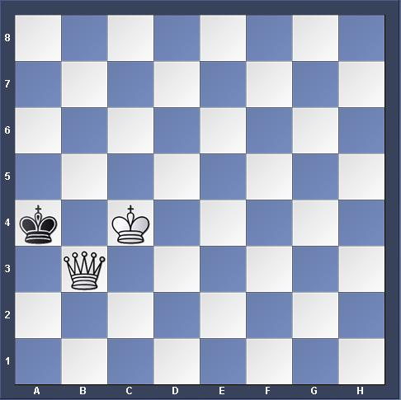 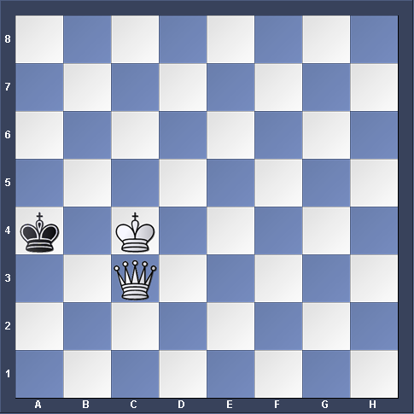   
 **Figure-1** **Figure-2**

1. **It's Black's move (In figure-3). Is this CHECKMATE?  
   Ans**. Yes or No
2. **It's Black's move (In figure-4). Is this CHECKMATE?   
    Ans**. Yes or No 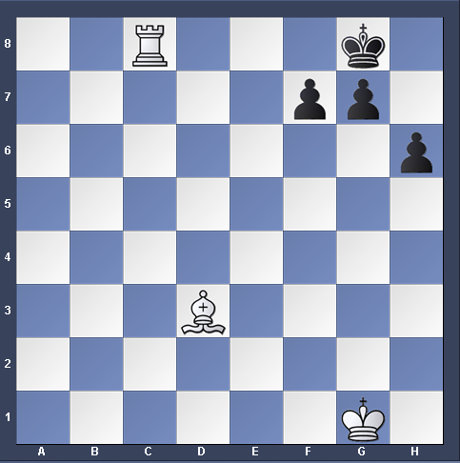 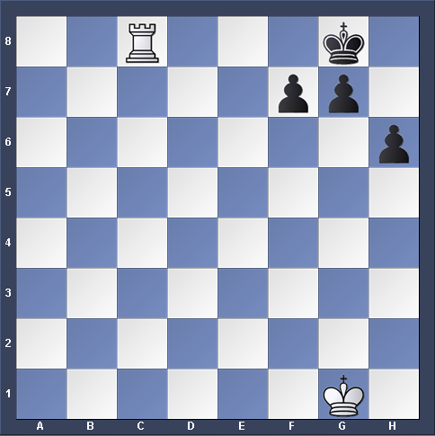   
    **Figure-3 Figure-4**
3. **Write down all the conditions when the game is declared as draw.**
4. **Can a king move to a square which is under attack by opponent’s piece?  
   Ans.**
5. **How should we play the opening moves?**
6. I play many pawn moves.
7. I bring the queen out as fast as possible.
8. I always attack right away.
9. I develop first the queenside pieces.
10. I develop very fast the kingside pieces and castle as soon as possible

**Ans.**

1. **Which is the only piece that must deviate from its usual movement to capture a piece?**
2. Rook
3. Knight
4. Bishop,
5. Queen
6. Pawn

**Ans.**

1. **When should we do castle?**
2. I castle when I feel like it.
3. To castle is just a waste of time. I rather develop a piece instead.
4. The king is usually pretty safe in the middle so I keep attacking that is more

Important than castling

1. I develop my kingside pieces and after that I castle as soon as possible.

**Ans.**

1. **If only the king is left, in how many moves does the opponent have to mate?  
    Ans.**
2. **In how many moves white can capture all the pawns? Ans.**

